Thumati Pavan Venkata Narendra Kumar

EMP-ID-289219

**Step 1:** Create a GitHub Repository naming it as Beginner-Project-2 (public)

**Step-2:** Open the git bash/VS code terminal.

**Step-3:** **Initialize Git** in the project folder using **git init** in VS Code terminal.

**Step-4**: Connect the remote repo on GitHub to the Vs code by using the command “**git remote add origin “link””** (Link is available in GitHub under code button).

**Step-5**: Use “**git pull origin main”** command to pull the files (like readme) from the remote repo to local repo.

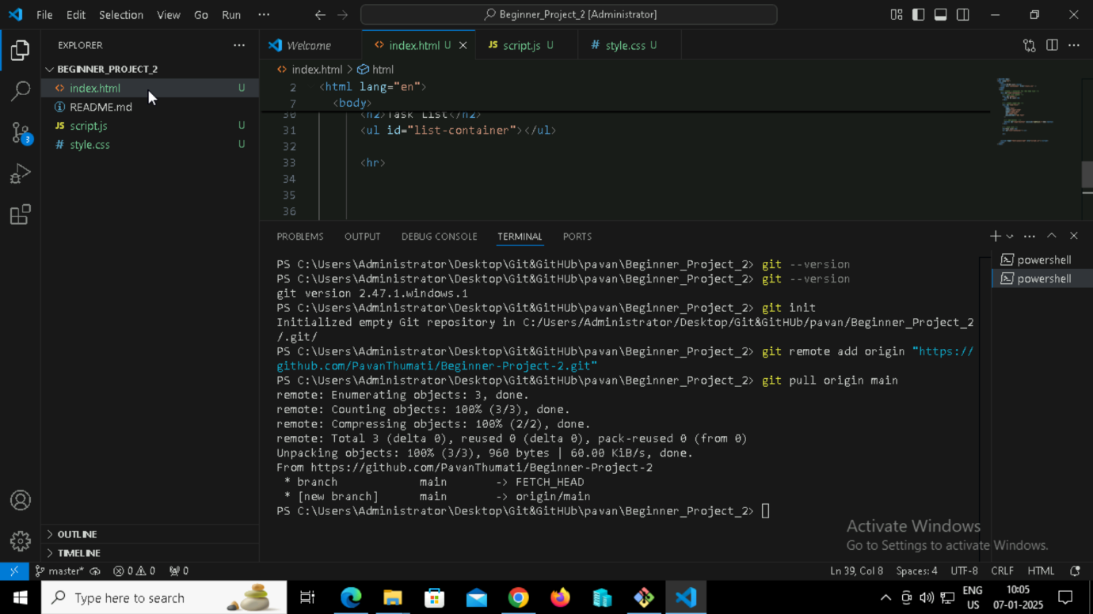

Figure 1:Initial commands.

**Step-7**: Create the files (index.html, style.css, and script.js) into the staging area by using “**git add .**”.

**Step-8**: To know the status of the files that are added to staging area type the “**git status”** command.

**Step-9**: Commit the changes by using “**git commit -m “Initial commit of web app”**”.

**Step-10**: Now push the files that are committed (saved) previously by using **“git push origin main”** command. Check whether the files have come/updated to GitHub if any error occurs follow the previous steps.

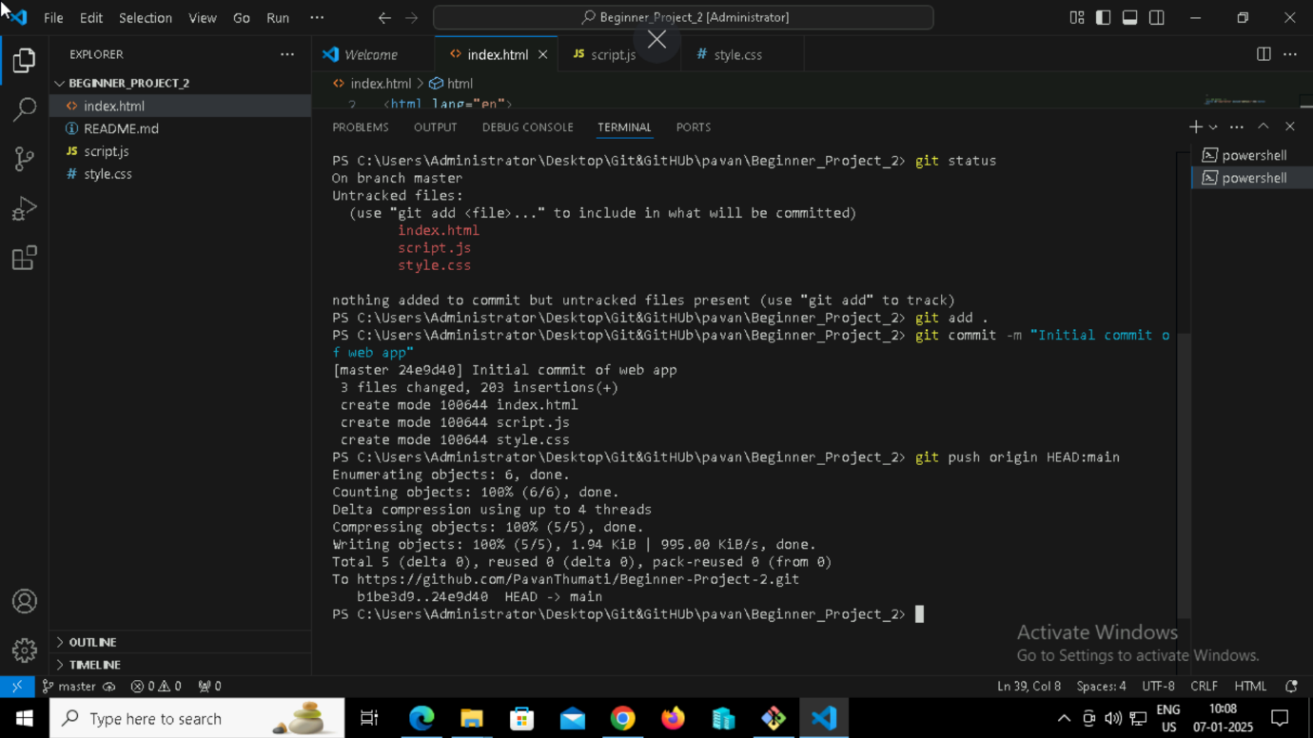

Figure 2:Pushing to GITHUB.

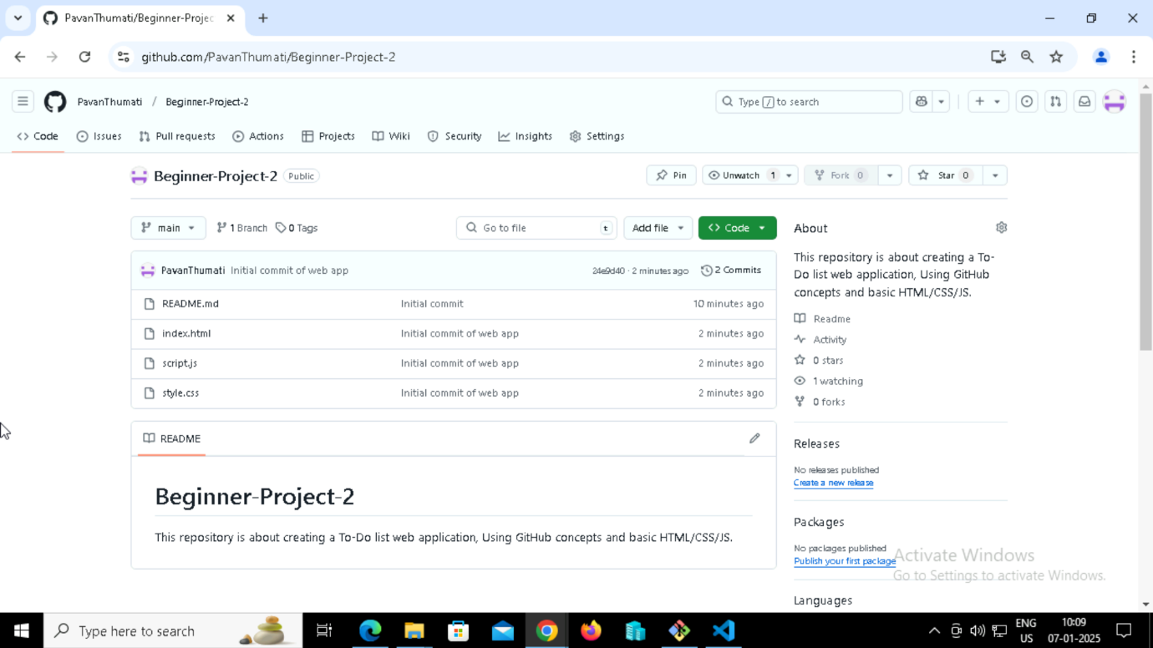

Figure 3: GitHub repo after pushing file.

**Step-11**: Go to settings -> pages and select the main branch and click save to deploy and after the completion of deployment click on the link provided by GitHub.

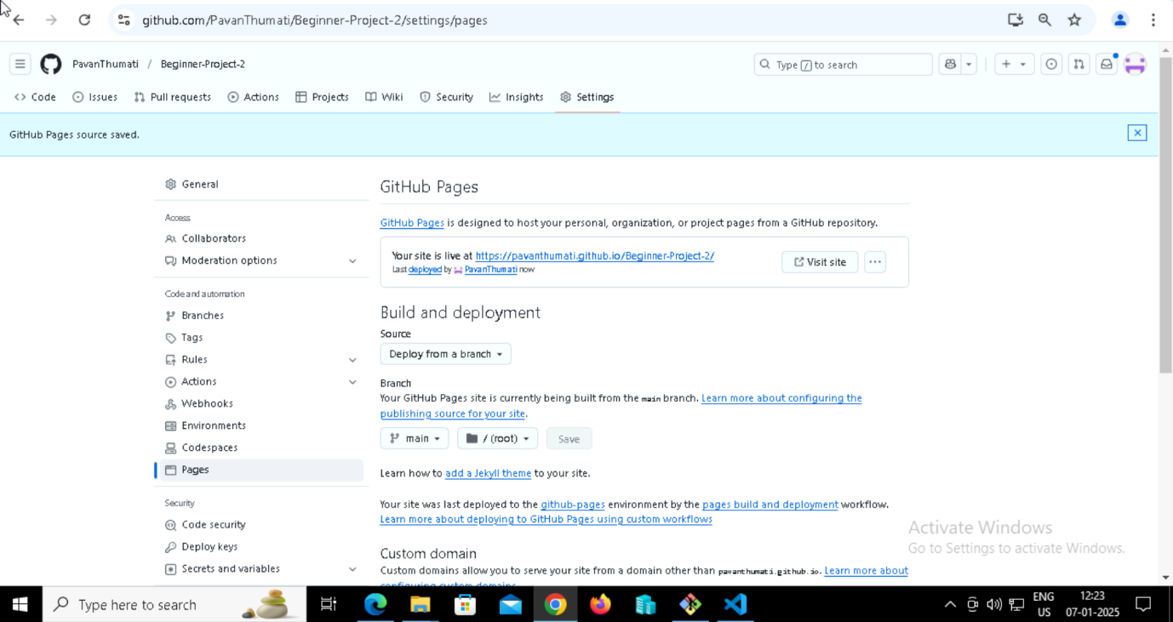

Figure 4:Link Created

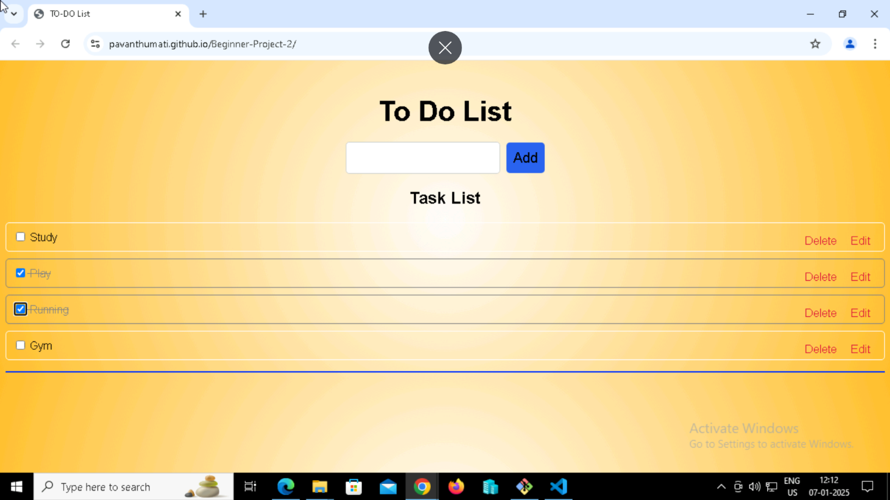

Figure 5: Web Application

**Step-12**: Add the new branch using “**git branch newFeature1**” command.

**Step-13**: Move to or check out the new branch to make the changes in HTML, JavaScript files.

**Step-14**: After adding new feature to the file, repeat the steps 7, 8, 9, and 10 (adding, committing, and pushing the files into new branch).

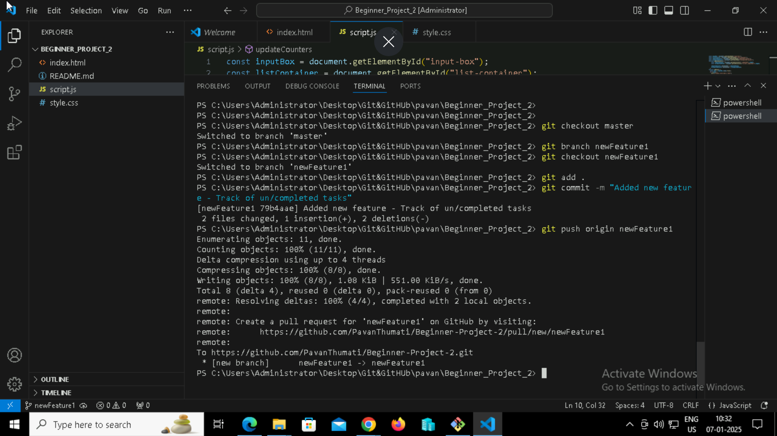

Figure 6: Adding, committing & pushing.

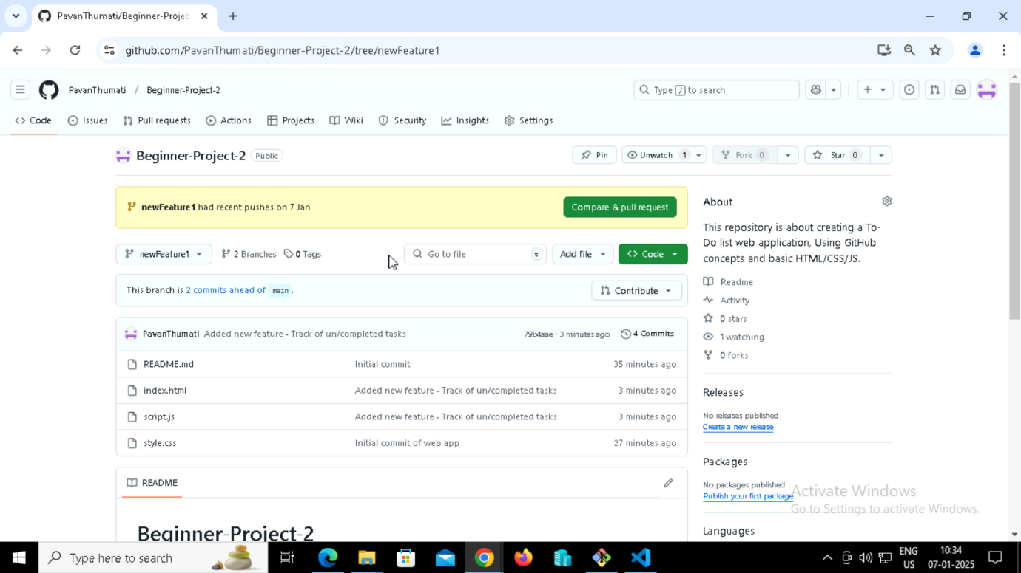

Figure 7: GitHub repo after pushing file.

**Step-15**: In GitHub repo create the pull request from new branch to compare the changes with main branch files.

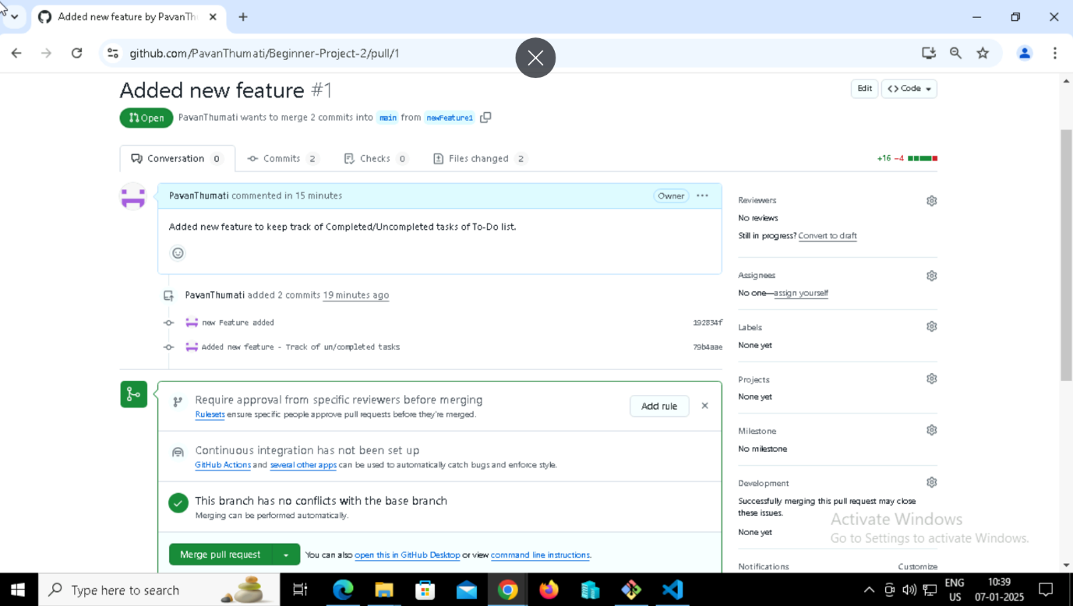

Figure 8: Pull request created.

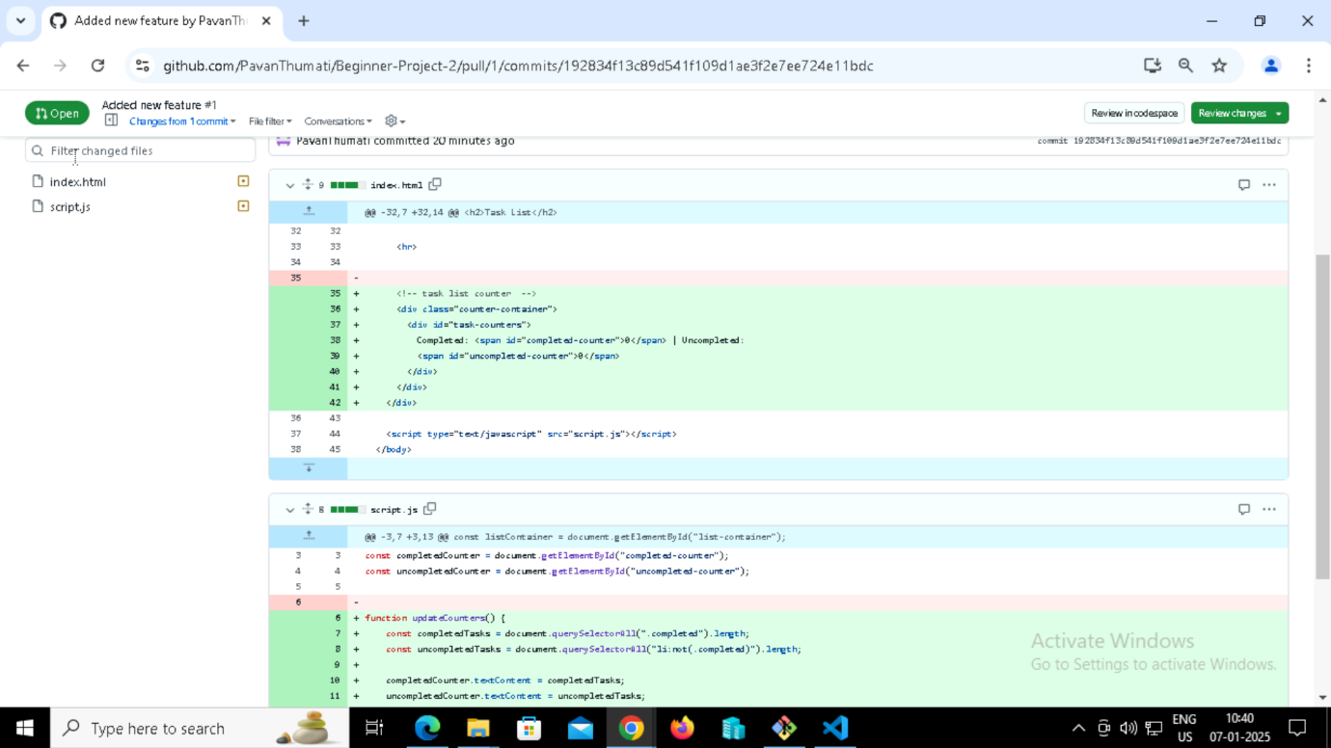

Figure 9: Comparing the changes with main branch's files.

**Step-16**: Merge the changes to the main branch.

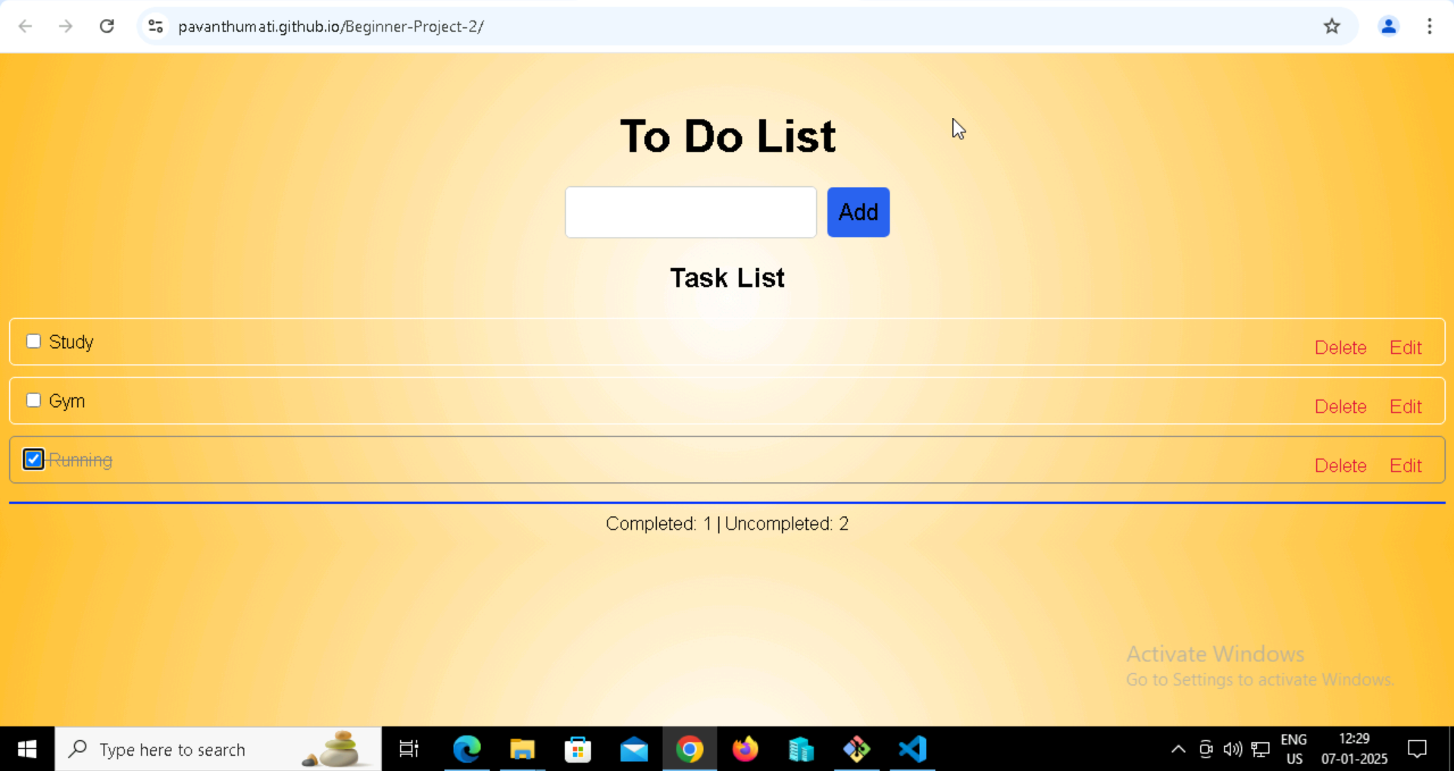

Figure 10: Web app after adding new feature.